Motorists & Marijuana Laws in Alaska, Colorado, Oregon, Washington D.C. & Washington
Social Policy Analysis & Advocacy Action Plan- Section I & II
Carleen Riley-Mercado
University of Louisville
April 2015

Motorists & Marijuana Laws in Alaska, Colorado, Oregon & Washington
According to changes in state and district laws, recreational marijuana use is legal for adults aged 21 years old or greater in Alaska, Colorado, Oregon, Washington, and Washington, D.C. A concerning consequences of making recreational use of marijuana legal includes more of the population driving while high. As an example, Colorado foresaw this difficulty, as “legal access to recreational marijuana by anyone in the state would likely lead to more people driving while impaired,” and so far, proponents predicting this trend have been correct, (Blake & Finlay, 2014, p. 375).
To better understand these changes, here is quick summary of the legislation passed: Colorado passed amendment 64 and Washington had the Washington Initiative 502 bill legalizing recreational marijuana on November 6, 2012 (Wallach & Hudak, 2013). Nearly two years later, Alaska, Oregon, and Washington, D.C. followed suit with the passage of Measure 2, Measure 91, and Initiative 71, respectively, on November 4, 2014 (Merica, 2014). A little over two years after cannabis legalization in Colorado and Washington, the social implications are becoming clear. As a result of this change in legislation, there have been significant changes in dangers to motorists from others driving high, a greater occurrence of patrol officers making DUI/DWI arrests, and a push towards more research aimed at controlling this public health concern.
Problem Definition
Drugged driving, defined by section 42-4-1301(1) of Colorado’s Vehicle and Traffic
Code (2015) states it is illegal for, “any person who is under the influence of…one or more drugs…to drive any vehicle in this state,” (para. 1). The percentage of motorists engaging in drugged driving is growing exponentially. The National Highway Traffic Safety Administration’s (NHTSA) latest survey indicated that nearly one in four drivers tested positive for at least one drug in their system while driving, and “the number of drivers with marijuana in their system grew by nearly 50%” from 2007 to 2014 (2015, para. 6). While these statistics are alarming, there is some disagreement in the general public regarding if driving while high on marijuana impairs a driver’s cognition and reaction skills.
To summarize most scientific research in this area, the results are mixed and fairly unclear. Most of these discrepancies can be accounted for through different research methodologies and the difficulty of field studies in this area, as researchers are often asked participants to recall their past behavior in natural settings, compared with a controlled, laboratory setting. Overall, most agree there has been a slight upsurge in serious car collisions in states were recreational marijuana use is legal, including a statistically significant increase in collision fatalities. Compton & Berning (2015) cite a population-based case control study of over 9,000 drivers nationwide, the largest study of its kind in the US, where drivers who tested positive for THC were 1.25 times more likely to crash than non-impaired motorists. Columbia University researchers from the School of Public Health expand on these findings by looking specifically at traffic fatalities and conclude, “Fatal crashes involving marijuana use tripled during the previous decade” (Thompson, 2014, para. 2). As these statistics continue to rise, researchers, public enforcement officials, politicians, and concerned motors have begun asking, what target population is affected the most by marijuana driving impairment?
The specific answer to this question also varies. To clarify, are we considering only the population most likely to drive with tetrahydrocannabinol (commonly known as THC, marijuana’s active psychoactive isomer) in their system? Or the more general driving population affected by this societal problem? To answer the first question, the National Institute on Drug Abuse summarizes that drivers aged 16-25 years old are most at risk for driving high on marijuana (2009, para. 6). A plethora of researchers conclude that young Caucasian males are most likely to drive with cannabis clouding their judgment, which fits well with the current research that this group is also most likely to engage in high-risk driving behaviors in general (Arcuri, 2013). However, those with a history of previous drug addiction are also more likely to drive with THC in their system, and like other drug addictions, this can affect any age, gender, race, or income level without discrimination (NHTSA, 2009). The only general trends about driving on marijuana also applies to general drug and alcohol use and addiction; that is impoverished populations and those with limited opportunities due to oppression or a criminal history are most affected. Driver impairment affects everyone sharing the road with that motorist, and so it should be general public health concern for many.
The reason this issue is quickly gaining attention is because of how the magnitude of the problem is growing exponentially. Through a literature review of 35 studies, researcher Arcuri (n.d.) found, “of those who use marijuana, between 43.1% and 82% reported having ever driven a vehicle shortly after using marijuana and between 23% and 80.3% reported having done so in the last 12 months, 76.1% reported having done so in the last month; and 21% reported having done so in the last week,” (para. 6). Given the prevalence of this problem, analysts have begun asking questions about what caused such an increase in drugged driving and what societal consequences are now facing because of this issue.
Causal, Ethical, & Ideological Analysis
Attitudes exhibiting a tolerance, and even an acceptance of marijuana use has led these five areas across the country to adapt their laws to legalize this drug. Marijuana has long been the most commonly used illegal substance in the last 50 years or so and it is likely the popularity of this substance played a key role in American’s view of marijuana general social acceptance. Blake & Finlay (2014) provide an example of this point, saying proponents to Colorado’s recreational legalization laws were very effective in appealing to the public with the argument that marijuana is like alcohol, and it’s responsible, adult consumption should be viewed the same way. Further, a February 2014 Pew Research Center poll stated 54% of Americans believe marijuana should be legal, up from 41% four years ago (as cited in Marris, 2015). As these statistics indicate on an individual and community level, many see this substance as acceptable if there is a financial gain through tax revenue, further employment opportunities, or generally spurs the economy.
On a familial level, there appears to be as many opinions as there are differences in households. Some view marijuana as a harmful substance and feel public education systems need to discourage all drug use. Others feel that marijuana is not as harmful as tobacco or alcohol, and note they are legal. The legality of these substances, and the large body of research which demonstrates their negative health effects are used as a counterargument that marijuana isn’t that bad, because science hasn’t consistently proved its dangers. Still others feel this only indicates that more money needs to be allocated towards research before are more definite answers reached. Finally, driving high is sometimes akin to drunk driving in some populations, except drunk driving is largely taboo and there are several campaigns in place to warn about that danger. Very recently, the Washington Traffic Safety Commission and the Colorado Department of Transportation (CODOT) began leading the way with campaigns, mostly comprised of humorous commercials with the latest scientific evidence, aimed at curbing the behavior of driving high on marijuana (Xavier, n.d.). Before this, many families, individuals, and communities seem to lack awareness on whether marijuana impaired driving. Without concrete evidence, families typically remain ambivalent on this topic, and so often young drivers often decided what was based on the opinions of their peer groups.
Even the federal government has taken a hands-off approach with this topic. TIME magazine writer Alex Altman (2014) summarizes that the, “Obama administration has urged law enforcement to let the legalization experiments play out,” feeling that guidance on a national level is not necessary at this point in time, (p. 36). The trend for high courts and our national legislative system to stay mute is also communicated through other researchers. Carcieri (2012) notes “, the Supreme Court is not where the action is on reform in this area. Indeed, the action is not even in the federal government, as Congress has long been intransigent on this issue,” (p.1014). Left with examining this drugged driving issue in local communities, three key trends are have become apparent. One trend is a growing need to pass additional legislation to help law enforcement officials combat drugged driving. The second commonality is increasing community prevention efforts, and the last is ensuring that reliable saliva testing measures are developed for field sobriety tests.
Rawl’s difference principle of Rawls’ distributive justice applies to drugged driving. Using this conceptual framework, inequalities in society should only be permitted when they benefit those in society who are the worst-off. Rawls would likely acknowledge that some drivers may receive pleasure from partaking in marijuana and then driving, yet would condemn these actions because increased traffic accidents. Rawls would surely say the momentary pleasure or convenience of high driver would not outweigh these consequences of families and friends losing someone due to a traffic fatality.
In contrast to the Rawls’ perspective, a utilitarian would say that the greatest good for the greatest number of people in the society is most important, and would oppose drugged driving because they would worry about how driver impairment would harm other motorists. Deputy General Attorney James Cole listed “preventing drugged driving” as one of its eight enforcement priorities because of his concern for the general driving public, an example of utilitarianism (Blake & Finlay, 2014, p.376). The majority of sober drivers must be taken into consideration, especially in the recent rise of drugged driving.
From a liberal viewpoint, some oppose research funds for saliva testing tools because they say it infringes on constitutional rights. To understand this viewpoint, current police protocols rely heavily on probable cause testimony and observations of inebriation. This is largely a subjective experience, and so the science used to support this is to also to test a possible offender’s blood for THC. However, as Blake & Finlay (2014) point out, blood testing is “far more invasive than the oral breathalyzer test typically used to test blood alcohol content and thus raises potential Fourth Amendment concerns,” (p. 376). Conservatives and liberals alike also debate the quantity of THC needed to be present, as the dissipation rate of marijuana in the body varies significant from person to person..
The issue of public awareness campaigns designed to inform the public about drugged driving is also be seen differently, with liberals encouraging humorous, personal account ads aiming for responsible use, whereas conservatives prefer factual information and an abstinence-only stance.
Liberals who advocate for less restrictive definitions of drugged driving are also known to bring some of controversial scientific opinions in on the debate. Marris (2015) exemplifies this, saying, “Scientists have demonstrated that pot impairs driving, though other researchers say high drivers often compensate with added caution,” (p. 17). These views vary, of course, and others redirect the conversation towards innovation of tools to aid police patrolmen, instead of biased opinions about driving safety in the name of science. Dr. Guohua Li, Director of the Center for Injury Epidemiology and Prevention at Columbia University, provides an example of saliva testing tool, although he acknowledges it is less reliable than a breathalyzer and not widely adopted (Thompson, 2014). However, Liberals and conservatives both do agree advocating for research funding is important
Gainers & Losers Analysis
How to combat marijuana impairment for drivers is complex, and typically evolves into rancorous debate. Blake & Finlay (2014) state that Colorado’s legislative house and senate committees exemplified this before Governor Hickenlooper signed into law additional protective measures for law enforcement, because of the spike in DUI/ DWI convictions. Similar to Colorado, some conservatives point to how these DUI/DWI charges in Oregon, Washington and Alaska are increasing state revenue. The demand for public defenders, attorneys, and all those in the judicial process also increases these professionals’ job security. Xavier (n.d.) provides the example that a convicted motorist in Washington could face up to a $5,000 fine, driver’s license suspicion, and even jail time. While increased revenue would place states as gaining, the financial impact, inconvenience, and social implications of jail time for those with DUI/DWI charges would place them as losers in this analysis.
Gainers also include scientists, researchers, and academics whose research is gaining attention. As an example of this, the NHTSA is partnering with the National Institute on Drug Abuse to complete driver simulator studies examining driver impairment. Innovation companies involved in testing measures to determine if a motorist is driving while impaired benefit from this societal trend, as focus and money is poured into this helping technology for police officers.
The increased number of drug-related traffic crashes benefits car dealerships, collision repair shops, and mechanics, repairs are needed or motorists obtain new transportation. However, those who have had their collisions fully covered under auto insurance likely will lower out-of-pocket costs than the total actual parts and labor cost, so the insuring auto companies are losers in this situation. Unfortunately, drug-related traffic fatalities have been trending upwards, and so the friends and families suffering loss are negatively affected. This impacts the funeral service community, who gains financially along with hospital emergency care services, as they profit from caring for accident-related injuries.
Police and law enforcement officials benefit from drugged driving because the high demand of crimes requires additional police staffing, and improves job stability. Further, elected officials are revising state budgets to ensure additional funding is available for proper traffic stop protocol training. However, less state funds are then available to address other societal issues, and politicians have more difficulty passing other bills.
Some tourists are more likely to visit Alaska, Oregon, Washington, Washington D.C. and Colorado because consuming marijuana while vacationing is appealing. This increases tourism revenue and affects drugged driving, because individuals also purchase rental cars and drive impaired. Related to this topic, marijuana dispensaries, growers, the illegal market including drug-dealing operations, and legally-operated companies profit from recreational marijuana use, yet this is not discussed here because it does not directly relate to drugged driving per se. It will be fascinating to see how states with legalized recreational marijuana will continue to combat drugged driving in the future, and the ripple effect those actions have among policy makers, key stakeholders, and the driving public. Will additional utilitarian-based legislation be passed in Alaska, Oregon, Washington D.C., and Washington, like there was in Colorado? Or will the key stakeholders who have benefited from drugged driving lobby other states to pass laws which legalize recreational marijuana too? What about patrol officers’ lessons learned as they adapt their practices to effectively handle marijuana DUI/DWIs; will the community perception of police be of respect or hatred as they arrest more drivers? As one can see, this issue remains very complex.
Section II
With the growing national trend of increased DUI/DWI charges and traffic fatalities because of cannabis impairment, policy reform is needed to help patrol officers fight this public health concern. This includes improving saliva testing technology for use in probable cause and field sobriety checks, implementing DRE officer training nationwide, and following Colorado’s examples of public awareness campaigns against drugged driving on a nationwide scale.
Current Drugged Driving Programs & Policies
Currently, the International Drug Evaluation and Classification Program, or DECP, is leading the way in effectively training police officers nationwide to detect motorists’ cannabis use. Attached in Appendix A is a one-hour evaluation form used in controlled settings like county/city jails and designed to judge the arrestee’s “vital signs…. judgment, information processing ability, coordination,” and outside factors which influences one’s behaviors, (DECP, 2015, para. 4).
Originally developed in 1979, the LAPD DRE (Drug Recognition Expert) program began around the metro Los Angeles area, as a desperate attempt to solve their growing drug epidemic. It has since grown exponentially, with 7 training sessions, teaching over 200 officers in the last fiscal year (The International Drug Evaluation and Classification Program, IDECP, 2015.) The IDECP (2015) notes the program is so successful it has gained the interest of media like The Police Chief Magazine and TIME.
Soon advocacy organizations like the Institute for Behavior and Health, Inc. and government-sponsored organizations like National Institute on Drug Abuse (NIDA), noticed the attention the DRE program was garnering, and began asking questions regarding proof the program worked, like the costs of the program, and the percentage of offenders patrol officers who could correctly identify impaired drivers.
The LAPD cooperated fully in providing this data, along with being transparent about their own successes and struggles. This information can still be found through the American Prosecutors Research Institute’s (APRI) web archives, the DECP (which governs current DRE certifications) and the LAPD “history” section of their public site.
DEC Funding & Alarming Data
As interest built, DRE programs were renamed DECs and full-scale programs were dialed down to pilots because of limited funding. Pilots ran in Arizona, Colorado, New York and Virginia in 1987, and then in Utah, California, and Indiana in 1992 with much success. At this point, the DEC program remained a state-level program for a handful of states nationwide, who would cooperate with larger, federal drug enforcement agencies like the United States Drug Enforcement Agency (DEA), among others. Yet, despite these efforts the National Highway Traffic Safety Administration (NHTSA), Substance Abuse and Mental Health Services Administration (SAMHSA), and National Association of Drug Court Professionals (NADCP) were still finding an alarming number of motorists engaged in drugged driving, and traffic fatalities remained a serious concern.
For instance, Dr. Guohua Li, Director of the Center for Injury Epidemiology and Prevention at Columbia University Medical Center, is quoted in a NBC News article that marijuana is increasingly involved in fatal crashes (Briggs, 2014). According to 2010 data, nationally 12.2% of drivers who died in collisions had cannabinol (marijuana remnants) appear on their toxicology reports (Briggs, 2014). Moreover, a 2014 CODOT report indicates 21.4% out of the 481 Colorado traffic fatalities involved a drugged driver in 2013, and a fourth of these cases involved marijuana.
To be clear, the issue is much larger than reckless, impaired driving in the states that have legalized recreational marijuana. The latest 2012 survey from SAMHSA indicates that 10.3 million Americans admitted to engaging in drugged driving (2013). Action was taken back in 1998, when Congress passed the Omnibus Drug Bill, resulting in the DEC program expansion to 33 states on short, trial basis, where funding typically lasted 3-5 years (LAPD, 2015). Once this federal funding expired, individual states were left utilizing avenues like police fundraisers, highway safety budgets, and other similarly earmarked streams of funding for DEC training in their locale.
Proposed Policy Changes
Policy Recommendation 1- The DEC program needs to be adequately funded and implemented, unlike its current patchwork funding approach, in all 50 states. This program needs to be implemented through the partnership of NHSTA and federal funding via a bill like the 1998 Omnibus Drug Bill.
Policy Recommendation 2- CODOT has recognized the importance of public awareness campaigns, which directly confronts common myths, misinformation in media headlines, and questionable driver impairment science. Because they have led the nation with their example, and have published statistics of their success and its reasonable cost, all other states should adopt their methods..
Policy Recommendation 3- Research funding through the NHSTA and large government organizations like SAMHSA should be made available to companies perfecting the technology around roadside saliva testing which detects THC or marijuana remnants. These tools would greatly assist DEC officers in the scientific evidence they need to enforce DUI/DWI arrests, and keep roadways safe nationwide.
Why Current Drugged Driving Laws Are Problematic
The discrepancy between drugged driving laws in various states is confusing, and a federal law which supersedes state differences would help immensely. To illustrate this point, in the following twelve states it is illegal to have any amount of marijuana in your system while driving, according to blood tests: Arizona, Delaware, Georgia, Illinois, Indiana, Iowa, Michigan, Minnesota, Pennsylvania, Rhode Island, Utah, and Wisconsin (NHSTA, 2010). In contrast to this, the three states where DUI statutes allow small amounts of marijuana are Nevada, Ohio, and Virginia (NHSTA, 2010). Whereas in other states, whether one is committing a crime or not by having marijuana in one’s body depends on who they are. For instance, the following five states say drug addicts and habitual offenders are forbidden from having drugs in their system while driving: California, Colorado, Idaho, Kansas, and West Virginia (NHSTA, 2010). Even more complicated, other states’ laws indicate testing positive for marijuana at a traffic stop is only problematic for minors. The two states that allow only small amounts of drugs in one’s system if 21 years of age or older are North Carolina and South Dakota (NHSTA, 2010). Lastly, one must consider that these drug “per se” laws are constantly in flux, and so this data may not even be accurate in the future.
Gainers & Losers Analysis
The implementation of the DEC program in all fifty states, increased public awareness campaigns for drugged driving, and better saliva roadsides tests ensure that the public at large understands the dangers of impaired driving, and can rest assured that those who break these laws will be stopped by trained police officers who can evaluate motorist impairment fairly.
The American Prosecutors Research Institute (APRI) (2004) specifically highlights two subsets of the population that would benefit from nationwide DRE training, motorists who appeared impaired due to medical conditions, and those situations in which motorist impairment is unclear. The APRI notes, “DREs have spared an untold number of people in the midst of medical crisis from being wrongfully charged with DUID,” (2004, p. 3). This saves in legal costs, along with social ramifications of false DUI/DWI claims. Further, the training of DEC officers lends the public “the benefit of the doubt” because if a patrol officer is uncertain, DEC training dictates the officer, “must find that a subject is not under the influence of drugs,” (American Prosecutors Research Institute, 2004, p.8). Ideologically and ethically, most agree that protecting motorists on the roadways is important, and ensuring that police officers have the tools and training needed to effectively do their job is part of this duty. Saliva tests utilized to test for marijuana use would also benefit researchers, who would gain financially and through fame if their technology was utilized similar to breathalyzers for roadside alcohol testing nationwide.
By changing drugged driving policies, those who would lose primarily include motorists who are guilty of driving while impaired, because they would be more likely to face arrest, legal fees, lose their license, and be court-ordered to attended drug and alcohol counseling courses. There would also be greater costs to police departments to ensure their patrol officers had adequate training, and the medical labs utilized to process any bloodwork, saliva, or other bodily findings, they would become busier with additional subjects detained. Hopefully, there would be a significant decline in traffic fatalities, and so hospitals and funeral homes would make less profits. That would be helpful because of a decrease in car collisions, and jails might experience additional overcrowding.
Now is the Time for Change
Keeping in mind the safety of motorists nationwide, a utilitarian perspective would
ensure the greatest safety for the greatest number of people, and would promote widespread police enforcement of drugged driving through public awareness campaigns, effective roadside testing tools, and additional DEC training for police. Not only from an ethical viewpoint, but from a statistical viewpoint, change is desperately needed now. The Institute for Behavior and Health (2014), “estimates that drugged driving causes 20% of crashes and marijuana is the most common of the drugs cited. That translates into 8,600 deaths, 580,000 injuries, and $33 billion in property damage each year in the United States,” (para. 6). Collections of powerful organizations like the Governors Highway Safety Association; Mothers against Drunk Driving (MADD) and NHTSA are joining forces to combat drugged driving, like they did in 2005 when forming a bipartisan Highway Safety Committee (Hayes, 2010). Through these ongoing partnerships, it was decided that “law enforcement leadership” was one on three areas which deserved their future focus, and the DEC program expansion was specifically mentioned as a tactic to achieve this goal.
This is the right time for this proposed policy change because the issue of drugged driving has become a hot topic in the media recently due to marijuana reform laws. The attention of the general public seems to be captured in light of recent events, and this is further spurring on additional research. As U.S. News reporter, Casey Leins so aptly names her recent article, “Drugged Driving Perplexes Scientists, Lawmakers,” there is still an emerging amount of nationwide data today regarding the true prevalence and incidence of drugged driving (2014).
Ingredients for Successful Policy Change
A non-negotiable aspect of these proposed policy changes includes public awareness campaigns that effectively fight the misleading information currently out there about drugged driving. WeSaveLives.org (2015) recalls recent news headlines, like USA Today’s “New study shows no link between marijuana use and car accidents,” The Washington Times’ “Stoned drivers are a lot safer than drunk ones, new federal data show,” and Los Angeles Times’ “Good news (?): marijuana doesn’t increase the likelihood of car crashes,” (para. 1). Information spread like this in the media is dangerous, because many readers are apt to just scan headlines, instead of asking critical thinking questions about the credibility of this information. The danger is that, without public awareness campaigns modeled after CODOT’s approach, these data goes unchallenged, and the assumptions that drugged driving law reform is not needed spreads. CODOT’s system directly addresses these claims, a credit to their current program.
Perfecting the technological concerns regarding THC-detecting saliva tests is also a key component of “testing the suspect for illegal substances” aspect of the DEC evaluation. As High Times (n.d.) noted, this medium has difficulty determining personal consumption and simply being present and testing positive due to environmental exposure (a.k.a. being in same room when marijuana was smoked). Further, as writer for Americans for Safe Access Rick Thompson (2014) points out, a positive saliva test fails to indicate key aspects of impairment like recency of use, frequency of use, or amount of consumption. Therefore, additional research to address these concerns is needed before patrol officers can utilize this technology. Currently, there is no FDA-approved technology to effectively test a motor for THC other than blood tests, which many are saying are invasive and potentially a violation of 4th amendment rights, and so this is an even less desirable choice. Saliva THC test can remain a wonderful option for DEC officers to utilize in their roadside tests, however the concerns noted above need to be effectively resolved first.
There are also needs for greater funding for both effective DRE training for officers and technology to improve current saliva tests, including more accurate assessments of these costs. Implementing the DEC program nationwide while at the same time encouraging more states to engage in drugged driving public awareness campaigns modeled after Colorado’s current program will surely be a mighty accomplishment, but well worth its efforts. To further aid DEC officers in their evaluation measures of impaired drivers, an effective roadside saliva THC test would be a wonderful addition, which would strengthen the effectiveness of the DEC program. These policies could be implemented to protect roadways nationwide with adequate funding, cooperation between many highway safety and anti-drug advocacy groups, and a little more research into current technologies.
ADVOCACY CAMPAIGN PLANNING FOR:
Tackling Drugged Driving where Recreational Marijuana Use is Legal
POSSIBLE SUPPORTIVE STAKEHOLDERS TO ENGAGE
Stakeholders include educators, media, legislators, law enforcement, government organizations, foundations created after traffic fatalities and community advocacy groups. Including these organizations is vital to combat drugged driving because each of these subgroups will address this growing social issue from a different viewpoint. For instance, educators and media may focus on public awareness campaigns, whereas legislators and law enforcement may be more swayed on based public health concerns and traffic fatalities. By inclusively involving as many of these organizations as possible, the issue of drugged driving is addressed most completely. Examples include the following:
- Educators: Sam Houston State University’s Impaired Driving Initiatives program, and others nationwide through educational institutions.
- Media: Science Daily (Magazine), Stop Drugged Driving.org, RADD, the Entertainment Industry’s Voice for Road Safety and similar groups
- Legislators: Representatives like U.S. Rep. Gerry Connolly, D-Va, who advocate for greater cannabis legalization and calls for additional research (Matthews, 2014). Also, the National Conference of State Legislators (NCSL)
- Law Enforcement: Police Chief Magazine, and The Alcohol and Drug Abuse Council for the Concho Valley (ADACCV) and similar local organizations
- Government Organizations: National Institute on Drug Abuse (NIDH), National Council on Alcoholism & Drug Dependence, U.S. Dept. of Health & Human Services, Office of National Drug Control Policy (ONDCP), United States Drug Enforcement Agency (DEA)
- Foundations Created after Traffic Fatalities: Victim Support Services (VSS), Washington State
- Highway Safety & Travel Organizations: AAA, Governor’s Highway Safety Association (GHSA), and the National Highway Safety Traffic Administration (NHSTA) & their subgroup safercar.gov, US DOT
- Community Advocacy Groups: Mothers Against Drunk & Drugged Driving (MADD) -& Youth for Road Safety

ADDRESSING OPPOSITION
- Media: High Times (publication), Cannabis Now Magazine,
- Legislators: U.S. Rep. John Mica, a Florida Republican and others like him who feel that we need to repeal the current recreational marijuana laws, stating the current drugged driving incidents are evidence enough that this is a public health concern (Matthews, 2014).
- Marijuana Law Reform Groups: European Coalition for Just & Effective Drug Policies (ENCOD), Hungarian Civil Liberties Union(HCLU)- Drugreporter, and Drug Policy Alliance (DPA)
- Local Medical Marijuana advocacy groups: Michigan-based National Patients’ Rights Association
- Community Advocacy Groups: Law Enforcement Against Prohibition (LEAP), Marijuana Policy Project (MPP), Students for Sensible Drug Policy (SSDP), Common Sense for Drug Policy (CSDP), Stop the Drug War & Drug Sense

Although the opposition is not likely strong enough to derail current laws passed regarding drugged driving, especially in states where recreational marijuana use is already legal, it may be enough to deter other states from additional passage of marijuana laws, and this could have a ripple effect on drugged driving incidents. Currently, the anti-drug and high safety programs already in place in most states would satisfactory address this issue, there just needs to be agreement that drugged driving should be a key focus of their efforts.
RESEARCH AND POLICY ANALYSIS
The following facts amassed by the National Association of Drug Court Professionals (2012) in their position paper, which would be immensely helpful in determining the dangers of marijuana as it relates to drugged driving:
- Marijuana use rates have risen substantially since 2007, whereas softening attitudes about the dangers of marijuana often precede an increase in marijuana use rates;
- Whereas marijuana impairs motor coordination and reaction time and is the second most prevalent drug (after alcohol) implicated in automobile accidents
- Whereas marijuana continues to negatively affect attention, memory, learning, and intelligence after the intoxicating effects of the drug have subsided;
- Whereas marijuana use consistently predicts a greater likelihood of involvement in crime and the criminal justice system;
FEASIBILITY
Financially, the DEC program has already expanded from a handful of states to 33 states through the 1998 Omnibus Drug Bill. As this previous success indicates, federal funding works well to expand DEC training for patrol officers. Therefore, expanding once again from 33 states to 50 states seems very feasible. Perhaps now is the window of opportunity even more so now than in the past, as the DEC program has amassed strong, quantifiable evidence of its success the last 36 years. With every passing year, the evidence grows stronger, as the LAPD (2015) has gathered information since its inception in 1979. Further, currently the IDECP (2015) governs the ever-expanding training and recertification of patrol officers for the DEC program. Therefore, programs are already well established that have been able to handle increasing demands for drugged driving police officer training. More so than ever before, there is now a well-established nationwide trend that drugged driving is increasing, which further perpetuates the need for the proposed policy change (NHSTA, 2015).
To enable police officers to combat the increase in drugged driving well, effective roadside saliva testing needs to be a tool available for DEC officers. This tools scientifically aids them in gathering the evidence they need to make a DUI/DWI arrest, and ensures the safety of roadways against impaired drivers. Further, it sends the message that motorists will not be able to “get away” with impaired driving, is less invasive than blood testing, and doesn’t violate the constitutional rights some worry about with blood testing. Per the publications Americans for Safe Access (2014) and High Times, saliva testing has already scientifically developed on a basic level, and addressing current complications in the research design of this tool, and funding its changes are likely to be emerging in coming years anyways. The demand for this tool is great per Institute for Behavior and Health, the opposition much less so, and scientifically, it seems very feasible (2014).
Politically, the recent legalization of recreational marijuana use has garnered the attention of media, legislators, educators, researchers and the public alike. Drugged driving is now a hot news topic, and so this has set the stage for public awareness campaigns to become very successful in warning the dangers of drugged driving. In order to be successful, it is logical to mimic a nationwide model after what has statistically worked very well in recent years for Colorado, through their Department of Transportation. It is simply building on the success of what has already been proved to work. Therefore, the combination of attention on this topic, along with CODOT’s transparency about how they were able to implement their awareness campaigns cost effectively, should encourage others to adopt the same model nationwide.
BASED ON ANSWERS FROM TEMPLATE, LIST THE IMMEDIATE NEXT 5 STEPS IN STARTING ADVOCACY CAMPAIGN
- Combine coalitions together to help secure advocates to lobby Congress, in our mission to prevent drugged driving
- Spread accurate, agreed upon data to support our claim that drugged driving is on the rise from credible, national sources like the National Highway Traffic Safety Administration (NHTSA)
- Expand DRE training and implementation to all 50 states would help ensure there is adequate coverage by patrol officers to enforce drugged driving laws.
- Advocate for a federal drugged driving law that supersedes confusing variations between states.
- Continue to hold productive, legislative and community conversations about the best way to prevent drugged driving in local areas most affected.

Appendix A: Screenshots of the an official DRE evaluation form
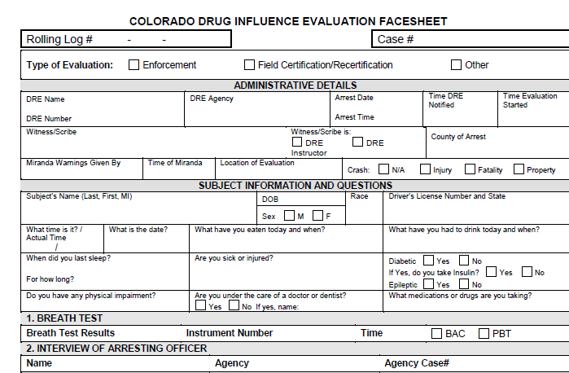

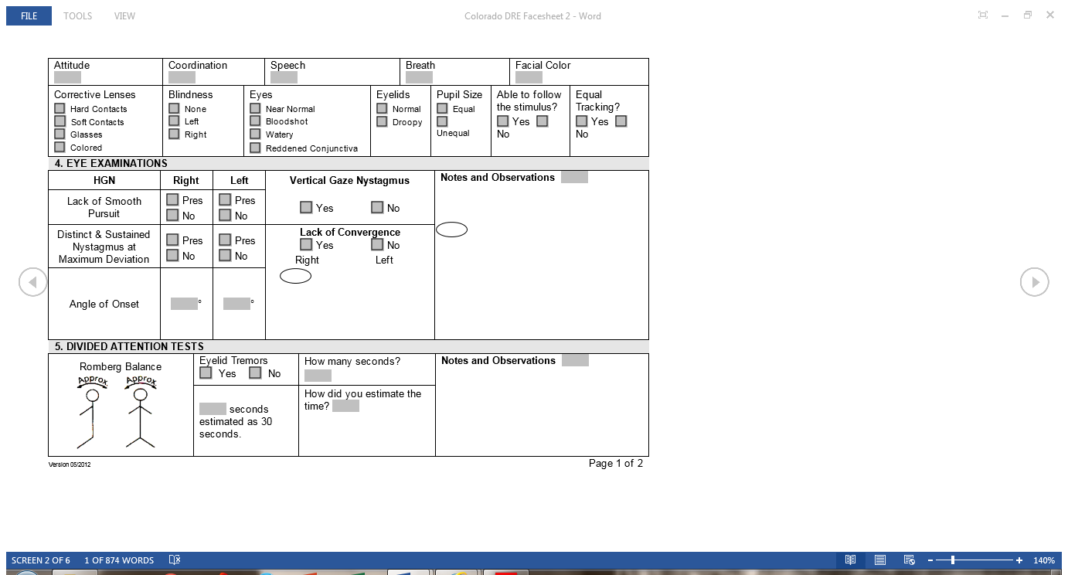
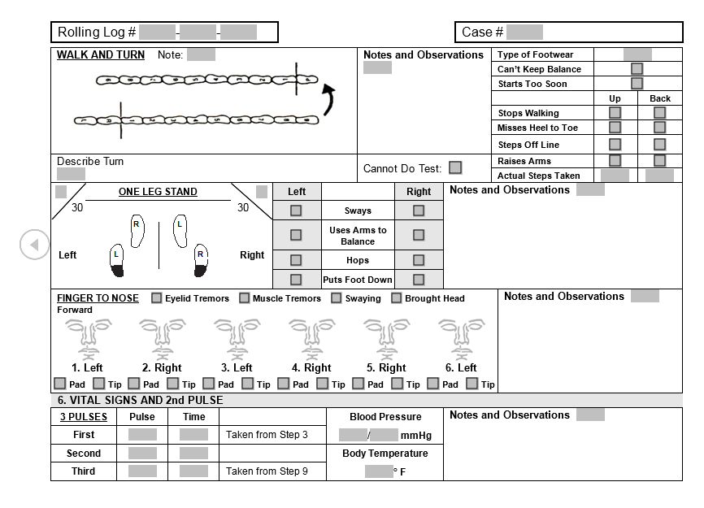
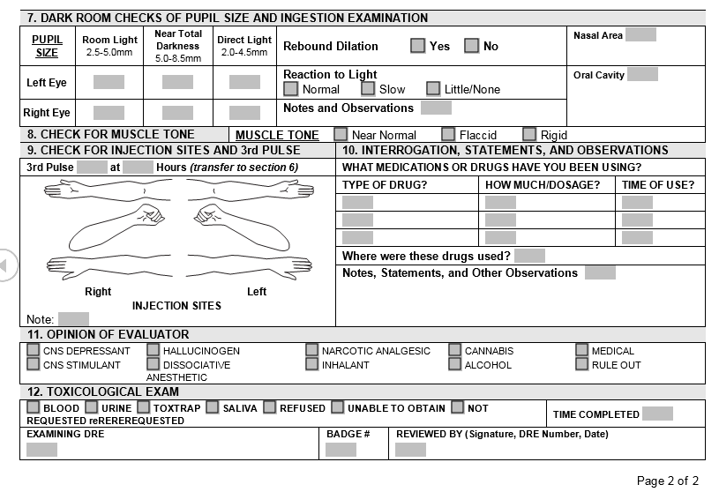
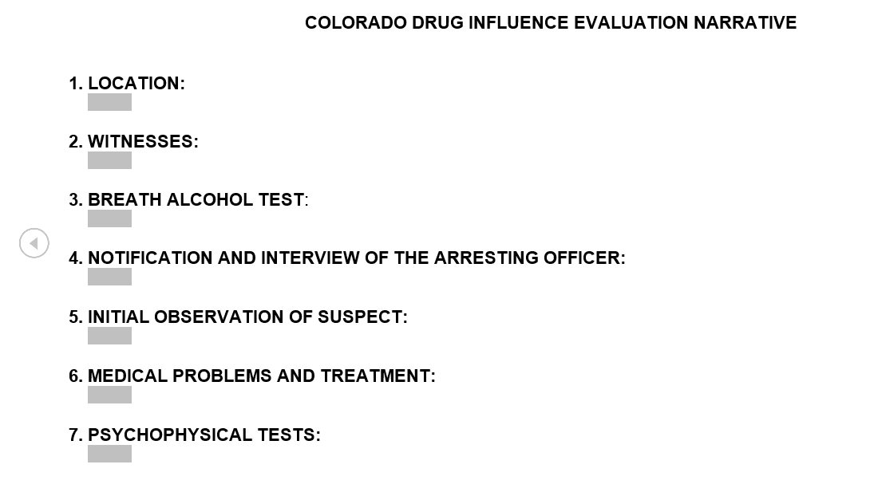
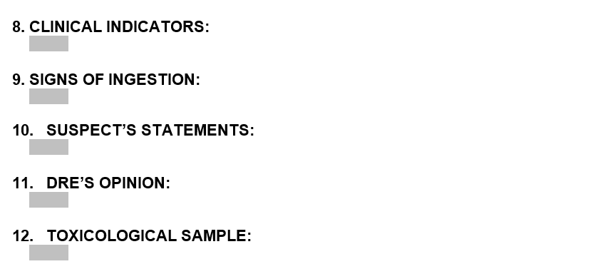

References
Altman, A. (2014, July 21). The pot paradox. TIME, 184(3), 36-39. Retrieved from http://time.com/2972323/the-pot-paradox/
American Prosecutors Research Institute (APRI). (2004). The drug evaluation and classification (DEC) program: Targeting hardcore impaired drivers. Retrieved from http://www.ndaa.org/pdf/drug_evaluation_classification_dec.pdf
Arcuri, A. (2013, June). Learn about marijuana: Science based information for the public. University of Washington Alcohol & Drug Abuse Institute. [Fact Sheet]. Retrieved from http://learnaboutmarijuanawa.org/factsheets/driving.htm
Blake, D. & Finlaw, J. (2014, July 1). Marijuana legalization in Colorado: Learned lessons. Harvard Law & Policy Review, 8(2), 359-380. Retrieved from http://eds.a.ebscohost.com.echo.louisville.edu/ehost/detail/detail?
vid=11&sid=464e2d9c-ee8b-4cbb-9d9cdccd7a8d6f36%40sessionmgr4001&hid=4111
&bdata=JnNpdGU9ZWhvc3QtbGl2ZQ%3d%3d#db=a9h&AN=98968750
Briggs, B. (2014, February 15). Pot fuels surge in drugged driving deaths. NBC News. Retrieved from http://www.nbcnews.com/health/health-news/pot-fuels-surge-drugged-driving-deaths-n22991
Carcieri, M. D. (2012). On the medicinal-recreational distinction in cannabis law. Denver University Law Review, 89(4), 1011-1016. Retrieved from http://connection.ebscohost.com/c/essays/86069752/medicinal-recreational-distinction-cannabis-law
Colorado Department of Transportation (CODOT). (2014, September). Drugged driving statistics. Retrieved from https://www.codot.gov/safety/alcohol-and-impaired-driving/druggeddriving/assets/fatal-data-drug.pdf
Compton, R. P. & Berning, A. (2015, February). Drug and alcohol crash risk. Traffic Safety Facts Research Note. DOT HS 812 117. Retrieved from http://www.stopdruggeddriving.org/news.html
Hayes, C. (2010, March). Combating impaired driving. The Police Chief Magazine. Retrieved from http://www.policechiefmagazine.org/magazine/index.cfm?fuseaction=print_display&article_id=2043&issue_id=32010
High Times. (n.d.). The saliva test. Retrieved from the High Times wiki at the following: http://www.hightimes.com/microsites/drugtest/drugtest_saliva.inc.php
Institute for Behavior and Health, Inc. (2014). Stop DUID 2014. StopDruggedDriving.org & NMS Labs. Retrieved from http://www.stopdruggeddriving.org/pdfs/2014StopDUIDReport.pdf
LAPD. (2015). The evolution of the DRE officer and program. Retrieved from http://www.lapdonline.org/special_operations_support_division/content_basic_view/1038
Leins, C. (2014, August 22). Drugged driving perplexes scientists, lawmakers. US News & World Report. Retrieved from http://www.usnews.com/news/articles/2014/08/22/drugged-driving-perplexes-scientists-lawmakers
Matthews, M. (2014, July 31). Congress examines pot and “drugged driving.” The Denver Post. http://blogs.denverpost.com/thespot/2014/07/31/congress-examines-pot-drugged-driving/111244/
Marris, E. (2015, January/February). Marijuana goes legit, but the future of research is hazy. Discover, 36(1), 17. Retrieved from http://discovermagazine.com/2015/jan-feb/6-marijuana-goes-legit
Merica, D. (2014, November 5). Oregon, Alaska, and Washington, D.C. legalize marijuana. CNN, U.S. Edition. Retrieved from http://www.cnn.com/2014/11/04/politics/marijuana-2014/
National Association of Drug Court Professionals (NADCP). (2012, December 15). Position statement on marijuana. Retrieved from http://www.nadcp.org/sites/default/files/nadcp/NADCP%20Board%20Position%20Statement%20-%20Marijuana.pdf
National Highway Traffic Safety Administration (NHTSA). (2009, December). A state-by-state analysis of laws dealing with driving under the influence of drugs. Retrieved from http://druggeddriving.org/pdfs/WalshStatebyStateDrugLawsAnalysis811236.pdf
National Highway Safety Traffic Administration (NHSTA). (2010, July). Drug per se laws: A review of their use in states. Retrieved from http://www.google.com/url?sa=t&rct=j&q=&esrc=s&source=web&cd=1&ved=0CB4QFjAA&url=http%3A%2F%2Fwww.nhtsa.gov%2Fstaticfiles%2Fnti%2Fimpaired_driving%2Fpdf%2F811317.pdf&ei=YRYYVe6xDIKiNrGUgegL&usg=AFQjCNE0Y9nwfwV5WyEuxA8xhDAyQBYXtw&sig2=F9RJKBtKv0majRSXJ2zxQg
National Highway Traffic Safety Administration (NHTSA). (2015, February 6). NHTSA releases two new studies on impaired driving on U.S. roads. Retrieved February 22, 2015 from the NHTSA wiki: http://www.nhtsa.gov/About+NHTSA/Press+Releases/2015/nhtsa-releases-2-impaired-driving-studies-02-2015
National Institute on Drug Abuse (NIDA). (2009, November). NIDA info facts: Drugged driving. Retrieved from https://www.uttyler.edu/clinic/files/drugged-driving.pdf
Stim, R. (2015). Colorado’s drugged driving law: Learn about the laws and penalties for driving under the influence of drugs (DUID) in Colorado. Driving Laws. Retrieved from http://dui.drivinglaws.org/resources/colorados-drugged-driving-law.htm
Substance Abuse and Mental Health Services Administration (SAMHSA). (2013, September). 2012 national survey on drug use and health: summary of national findings. Publication No. (SMA) 13-4795. Retrieved from http://archive.samhsa.gov/data/NSDUH/2012SummNatFindDetTables/NationalFindings/NSDUHresults2012.htm
The International Drug Evaluation and Classification Program (IDECP). (2015). Drug recognition experts (DRE): History & development. Retrieved from http://www.decp.org/experts/
Thompson, D. (2014, February 4). Fatal car crashes involving pot use have tripled in the US, study finds. HealthDay: News for Healthier Living. Retrieved from http://consumer.healthday.com/public-health-information-30/marijuana-news-759/fatal-car-crashes-involving-pot-use-have-tripled-in-u-s-study-684515.html
Thompson, R. (2014, April 18). Roadside saliva testing for marijuana use gets House hearing in Michigan. Retrieved from http://www.safeaccessnow.org/roadside_saliva_testing_for_marijuana_use_gets_house_hearing_in_michigan
Wallach, P. & Hudak, J. (2013). Comparing legal marijuana systems in Colorado & Washington. Online comparison chart from Brookings, Inc. Retrieved from http://www.brookings.edu/~/media/research/files/papers/2014/07/colorado-marijuana-legalization-succeeding/comparing-legal-marijuana-table.pdf
WeSaveLives.Org. (2015, March 4). Did the media promote stoned driving? WeSaveLives.Org. Retrieved from http://wesavelives.org/did-the-media-promote-stoned-driving/
Xavier, A. (n.d.) Washington states prepares for more marijuana DUIs. DUI DWI Foundation. Retrieved from http://www.duifoundation.org/news/washington-state-prepares-for-more-marijuana-duis.html
USE BOTH SECTION I and SECTION II Rubric Feedback/Scores
To revise and combine the Sections into a Final Paper
(Maximum of 20 pages excluding Cover page and Reference page)

